第5章 二维游戏场景绘制
英雄快跑
（一）基础知识
Tiled Map编辑器制作游戏地图、序列帧动画、碰撞检测
- Tiled Map编辑器制作游戏地图
- 加载游戏地图
- 添加玩家（序列帧动画）
- 单点触摸屏幕，控制英雄上跳
- 游戏地图的移动
- 玩家下落，落到地面（碰撞检测）
- 游戏结束

（二）Tiled Map编辑器制作游戏地图
1、创建游戏地图
新建一个游戏地图，地图大小设置如下：
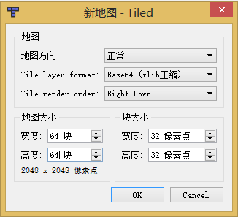
2、编辑游戏地图
通过Tiled Map编辑器编辑一个大型游戏地图，如下图所示。
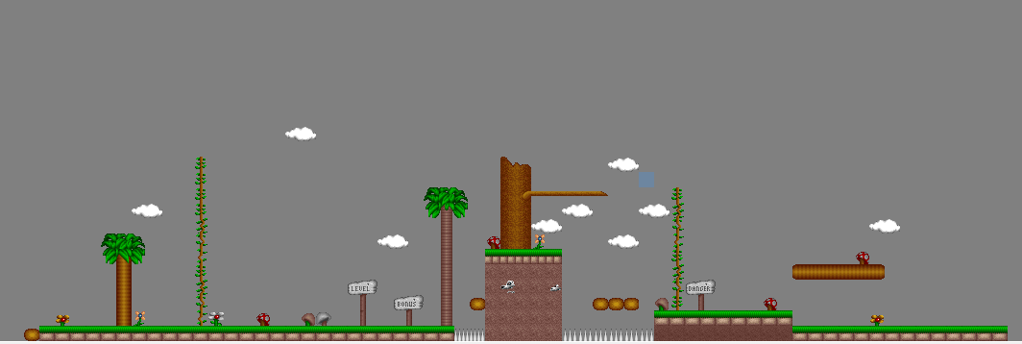

3、记录游戏地图中砖块的GID值
并记录下每个要作为地面的图块的GID值，GID值显示在地图编辑器的左下角，如下图中方括号中存放的值即为选中方块的GID值。
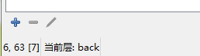
4、导出游戏地图
将制作好的地图导出为tmx文件。接着创建一个Cocos2d项目，将制作好的地图和图片资源文件一起放到新建好的项目的Resource文件夹中。

（三）配置文件与游戏管理文件
1、游戏配置文件
游戏需要新建一个Config.h的头文件，此文件用来定义游戏中需要的参数，包括玩家、地图的标记、玩家资源的相关参数、资源路径等等。
using namespace std;

static const int PLAYER_TAG = 110; // player tag
static const int MAP_TAG = 111; // map tag
static int PLAYER_WIDTH = 100; // player img width
static int PLAYER_HEIGHT = 100; // player img height
static int PLAYER_JUMP_SPEED = 30; // player jump speed

static string MAP_TMX_FILE_PATH = "Chapter05/MoveAndControl.tmx";
static string MAP_BG_LAYER_NAME = "back"; // map background layer name

static int MAP_FLOUR_NUM = 6;
static int MAP_FLOUR[] = {7,8,151,170,171,172};

static string GAME_OVER_TIPS = "Game Over!"; // game failed tips words
static string GAME_SUCCESS = "Success!"; // game success tips words

// fnt file path
static string TIPS_FNT_PATH = "fonts/futura-48.fnt";

// player img path
static string PLAYER_IMG_PATH[4] = {
"Chapter05/player/player1.png",
"Chapter05/player/player2.png",
"Chapter05/player/player3.png",
"Chapter05/player/player4.png"
} ;

enum Dir
{
STOP,
UP,
DOWN
};

2、游戏的管理文件
GameManager.h类
#include "cocos2d.h"
USING_NS_CC;
using namespace cocos2d;

#define GM() GameManager::getInstance()

class GameManager : public Ref
{
public:
GameManager();
virtual ~GameManager();
virtual bool init();
static GameManager* getInstance();

public:

// 获取精灵相对于地图的坐标
Vec2 getMapPosition(TMXTiledMap* map, Node* node);

// 获取精灵指定位置的图块编号
int getTileID(TMXTiledMap* map, Node* node);

private:
static GameManager* m_gameManager;
};

GameManager.cpp
#include "GameManager.h"
#include "Config.h"

GameManager::GameManager(){}

GameManager::~GameManager()
{
m_gameManager = NULL;
}

bool GameManager::init()
{
return true;
}

GameManager* GameManager::m_gameManager = NULL;
GameManager* GameManager::getInstance()
{
if (m_gameManager == NULL)
{
m_gameManager = new GameManager();
m_gameManager->init();
}
return m_gameManager;
}

Vec2 GameManager::getMapPosition(TMXTiledMap* map, Node* node)
{
// 玩家相对于屏幕的坐标
float px = node->getPositionX();
float py = node->getPositionY()-node->getContentSize().height/2;

// 地图相对于屏幕的x坐标
float mx = abs(map->getPositionX());

float my = 0;

// 玩家相对于地图的坐标
return Vec2(px + mx, py + my);
}

int GameManager::getTileID(TMXTiledMap* map, Node* node)
{
Vec2 current = getMapPosition(map, node);
return map->getLayer(MAP_BG_LAYER_NAME)->getTileGIDAt(Vec2((int)(current.x/map->getTileSize().width),(int)(map->getMapSize().height-1-current.y/map->getTileSize().height)));
}

（四）加载游戏地图
MapScene.cpp文件中。
void MapScene::loadMap(std::string mapPath)
{
// 加载地图
auto map = TMXTiledMap::create(mapPath);
if (map != NULL)
{
this->addChild(map,2);
map->setTag(MAP_TAG);
map->setPosition(Vec2(0, 0));
} else
{
CCLOG("load map failed!");
return ;
}
}

（五）添加玩家（序列帧动画）
void MapScene::addPlayer(Vec2 pos)
{
// 玩家跑动动画
Vector<SpriteFrame* >frameVector;
for(int i=0;i<4;i++)
{
auto spriteFrame = SpriteFrame::create(PLAYER_IMG_PATH[i], Rect(0,0,PLAYER_WIDTH,PLAYER_HEIGHT));
frameVector.pushBack(spriteFrame);
}
auto animation = Animation::createWithSpriteFrames(frameVector);
animation->setDelayPerUnit(0.07f);
auto animate = Animate::create(animation);

// 添加玩家
auto player = Sprite::create();
player->setTag(PLAYER_TAG);
player->runAction(RepeatForever::create(animate));
this->addChild(player,10);
player->setPosition(pos);
}

（六）触屏监听
void MapScene::addTouchListener()
{
// 加入触摸的处理
auto listener = EventListenerTouchOneByOne::create();
listener->onTouchBegan = CC_CALLBACK_2(MapScene::onTouchBegan, this);
Director::getInstance()->getEventDispatcher()->addEventListenerWithSceneGraphPriority(listener, this);
}

bool MapScene::onTouchBegan(Touch *touch, Event *unused_event)
{
if (!this->m_isJump) {
m_isJump = true;
m_jumpDir = Dir::UP;
}
return true;
}

（七）游戏结束
void MapScene::success()
{
auto tips = Label::createWithBMFont(TIPS_FNT_PATH,GAME_SUCCESS);
Size visibleSize = Director::getInstance()->getVisibleSize();
tips->setPosition(Vec2(visibleSize.width/2, visibleSize.height/2));
this->addChild(tips,10);
}

（八）游戏地图的移动与碰撞检测的实现
void MapScene::update(float t)
{
auto player = this->getChildByTag(PLAYER_TAG);
auto map = (TMXTiledMap *)getChildByTag(MAP_TAG);

// 玩家相对于屏幕的坐标
float player_screen_x = player->getPositionX();
float player_screen_y = player->getPositionY()-player->getContentSize().height/2;

// 地图相对于屏幕的x坐标
float map_screen_x = abs(map->getPositionX());
float map_screen_y = 0;

// 玩家相对于地图的坐标
float player_map_x = player_screen_x + map_screen_x;
float player_map_y = player_screen_y + map_screen_y;

// 不跳动时遇到非地面图块自动下落
if((int)(player_map_y / map->getTileSize().width) >= 0)
{
int playerTiledID = map->getLayer(MAP_BG_LAYER_NAME)->getTileGIDAt(Vec2((int)(player_map_x/map->getTileSize().width),(int)(map->getMapSize().height-1-player_map_y/map->getTileSize().height)));
if ((m_isJump == false)&&(m_jumpDir == Dir::STOP)&& (playerTiledID != 8) && (playerTiledID != 7)
&& (playerTiledID != 151) && (playerTiledID != 170) && (playerTiledID != 171) && (playerTiledID != 172)) {
m_isJump = true;
m_jumpDir = Dir::DOWN;
m_jumpSpeed = 2;
}
}

// 处理玩家的跳跃
if (m_isJump) {
if (m_jumpDir == Dir::UP) {
player->setPositionY(player->getPositionY() + m_jumpSpeed);
m_jumpSpeed -= 2;
if(m_jumpSpeed <= 0)
{
m_jumpDir = Dir::DOWN;
}
}else if(m_jumpDir == Dir::DOWN)
{
// 用于记录玩家是否落到地面上
bool check = false;

for (int i = 0; i < m_jumpSpeed; i += 2) {

// 计算当前玩家相对于地图的坐标
float player_screen_x = player->getPositionX();
float player_screen_y = player->getPositionY()-player->getContentSize().height/2 + i;

// 地图相对于屏幕的x坐标
float map_screen_x = abs(map->getPositionX());
float map_screen_y = 0;

// 玩家相对于地图的坐标
float player_map_x = player_screen_x + map_screen_x;
float player_map_y = player_screen_y + map_screen_y;

// 获取玩家脚下的地图块的编号
if (player_map_y/map->getTileSize().width >= 0) {

int tiledID = map->getLayer(MAP_BG_LAYER_NAME)->getTileGIDAt(Vec2((int)(player_map_x/map->getTileSize().width),(int)(map->getMapSize().height - 1 - player_map_y/map->getTileSize().height)));
if (tiledID == 8 || tiledID == 7 || tiledID == 151 || tiledID == 170 || tiledID == 171 || tiledID == 172) {
check = true;
player->setPositionY((int)(player_screen_y + player->getContentSize().height/2 - 6));
m_jumpSpeed = PLAYER_JUMP_SPEED;
m_jumpDir = Dir::STOP;
m_isJump = false;
break;
}
}

if (player_screen_y <= -80) {
gameOver(); // 角色死亡
}
}
if(!check)
{
player->setPositionY(player->getPositionY() - m_jumpSpeed);
m_jumpSpeed += 2;
if(m_jumpSpeed > PLAYER_JUMP_SPEED)
{
m_jumpSpeed = PLAYER_JUMP_SPEED;
}
}
}
}
this->getChildByTag(MAP_TAG)->setPositionX(this->getChildByTag(MAP_TAG)->getPositionX()-3);
// 滚动背景地图
int mapWidth = map->getMapSize().width*map->getTileSize().width;
int visibleWidth = Director::getInstance()->getWinSize().width;
if(map->getPositionX() < -(mapWidth-visibleWidth))
{
map->setPositionX(-(mapWidth-visibleWidth));
// 地图静止后移动角色
player->setPositionX(player->getPositionX() + 3);
if(player->getPositionX() > visibleWidth )
{
player->setPositionX(visibleWidth );
this->unscheduleUpdate();
this->removeChildByTag(PLAYER_TAG);
success();
return;
}
}
}

(九)初始化游戏
bool MapScene::init()
{
if ( !Layer::init() )
{
return false;
}

m_isJump = false;
m_jumpDir = Dir::STOP;
m_jumpSpeed = PLAYER_JUMP_SPEED;
m_gameOver = false;

Size visibleSize = Director::getInstance()->getVisibleSize();
Vec2 origin = Director::getInstance()->getVisibleOrigin();

// 加载地图
loadMap(MAP_TMX_FILE_PATH);

// 添加玩家
addPlayer(Vec2(80,40));

// 游戏逻辑
this->scheduleUpdate();

// 添加触屏侦听
addTouchListener();

return true;
}

（十）游戏运行后的效果如图。
